**Objectives:**

* To begin planning for the next project to be undertaken by the Grade 12 team.
* To apply the Planning and Analysis phases of the Software Design lifecycle to define, structure, and document the objectives and timelines for the project.

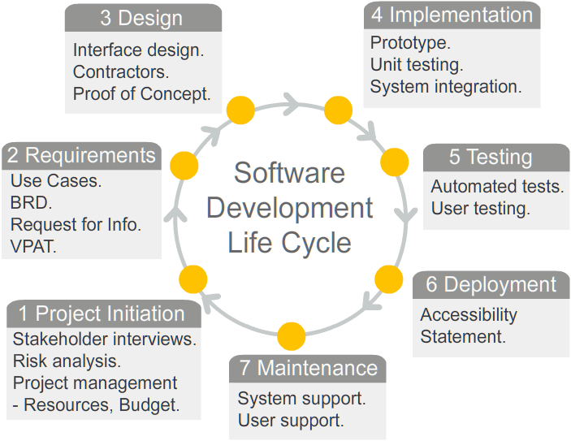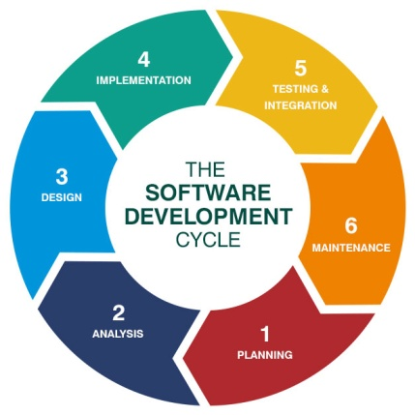

1. Brainstorm with your team the high level definition of your next project. Summarize your thoughts on the following topics.
   1. The look and feel of your project. (i.e. User interface and experience.)

We’re planning on having similar style states like the Super Mario Bros game. We will have a title screen where you select the game mode and the score and how many people are playing the game. We will have the actual game that states whether you play the game and a split screen where it shows your lives and the world.

A 2D side scroller that portrays a simple plot to achieve a quality standard in gameplay and variation in level design (Similar to classics like doom).

* 1. The operation and key objectives regarding how your project works.   
     (i.e. Internal code logic.)

Gameplay mechanics inspired of side scrollers such as Super Mario, Rayman Sonic the Hedgehog, and Megaman. With a 2D- Cartoon based design .

**Program Logic:**

Sprites (2D Models) Gameboard/main architecture (geometry), Gameplay functionalities and possibilities, and even Sound

* 1. The tools and java packages (e.g. Swing) and Assets (e.g. graphics) that you will need to implement your project.

Java Swing, LibGDX Game development library, and Game programming concepts

* 1. What new things you will have to learn and the new skills you will have to develop to implement your project.

Java Swing, LibGDX Game development library, Game programming concepts, like the states, game loop, and movements. Sprites / Pixel Art cropping, Mouse / Key input for actions.

* 1. The "would be nice" features of your project that might not be possible to achieve given your skill set and timelines.

**UI / Screen Design:**

-Graphical settings to give users a different/preferred perspective

-Clean UI that can be interfaced with a mouse

-Multiple Levels + Level select

-Pipe system to traverse through areas

-Game Save Options

-Cheat Codes and secrets for speed runners

**Player Details:**

-Normal Mixtape

-Mixtape on fire as a power up

-Shoots fireballs as an ability

-Dorito bag as coin’s

-Grow (Health) - Taco

-1 up - Coin / Penny

* 1. The "cannot live without" features of your project that must be achieved.

**Keyboard Controls:**

Z = Fire / Speed

X = Jump

Arrow Left = Go Left

Arrow Right = Go Right

Arrow Down = Crouch / Go inside Pump(Downwards)

T = Take ScreenShot

I = Info

K= key changer

**In game Features:**

-Final Boss Fights

-In game secrets/collectibles

-Platforming (jumping) on structures

-Special/Secret Worlds (Completion Reward)

**Overall Description:**

To have Rahulio realize his full potential within his quest to

become truly cool. As he overcomes a journey through his

life's desires and evil.